# DataAnalyticsWithTableau

**Name:G.Jayachandra**

**Team Member – 3 Assignment - 3**

*SupermarketSalesDataAnalysisReport–InteractiveDashboardusing Tableau*

**Objective:**

This dashboard analyzes historical sales data from a supermarket chain across threebranches(A,B,C)overa3-monthperiod.Itprovidesvisualinsightsinto sales trends, customer behavior, and performance by product category.

**ProcessFollowed:**

1. UploadedDatasettoTableaufromExcel.
2. Removedunnecessarycolumns.
3. Createdvisualizations:
   * Bar Chart
   * Pie Chart
   * StackedBarChart
   * Line Chart
   * BubbleChart
   * DonutChart
   * Area Chart
   * TextTable
   * HighlightedTable
   * WordCloud
   * Funnel Chart
   * Waterfall
   * KPITiles
4. Combinedvisualizationsintoasingleinteractivedashboard.

# Dashboard:

**SuperMarketSalesdashboard:**

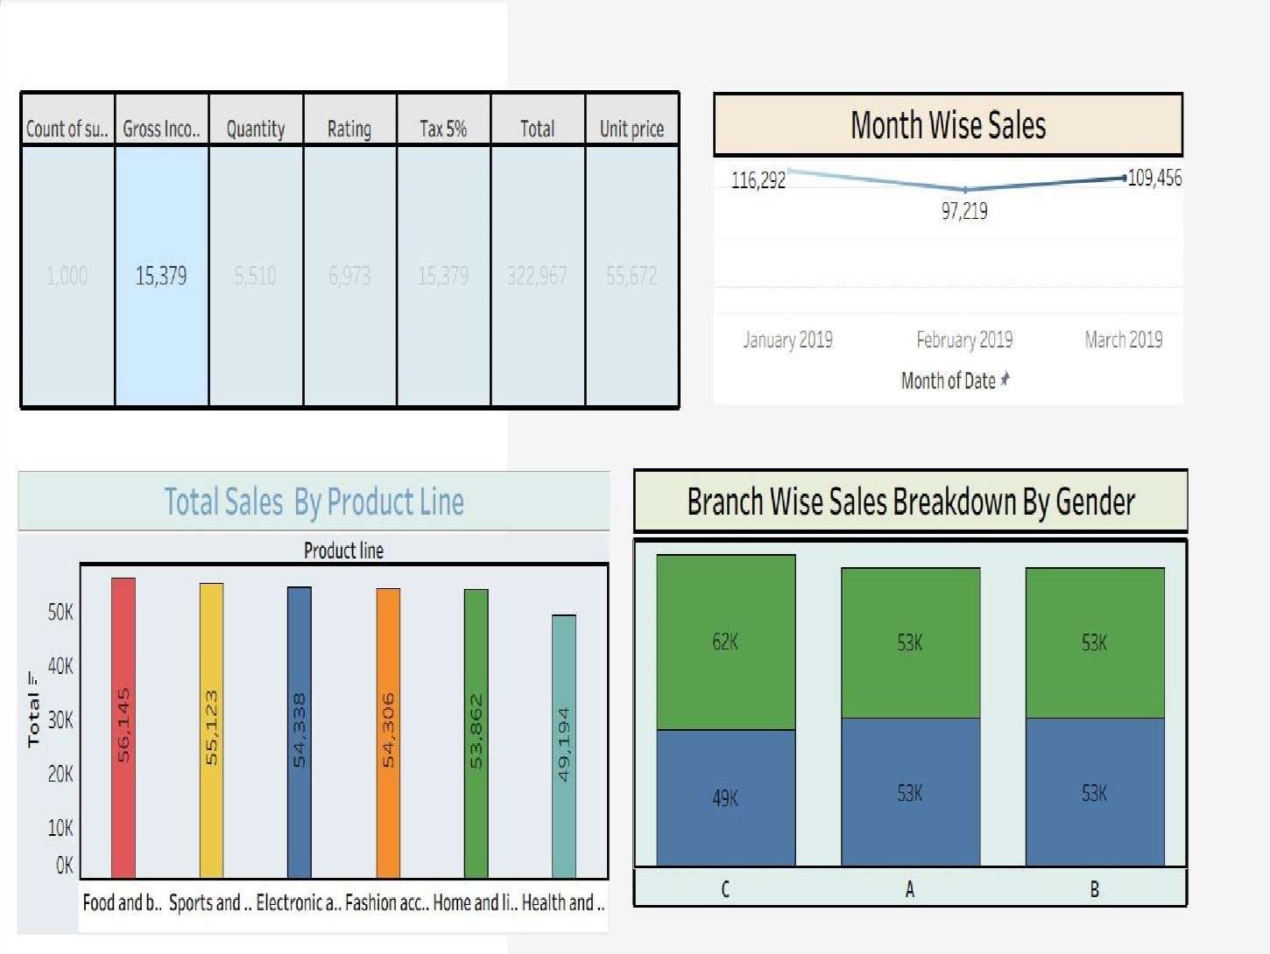

**SuperMarketSalesdashboard:**

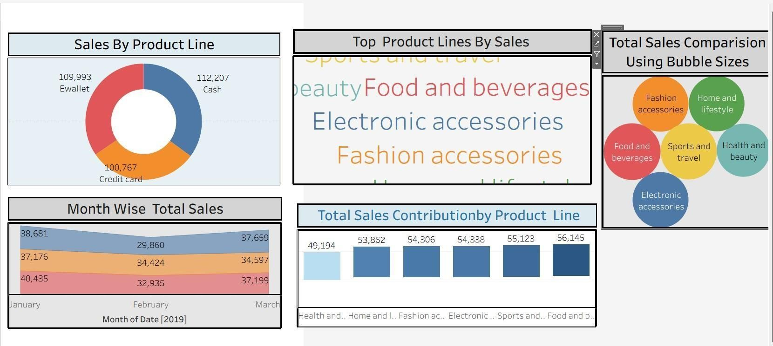

**SuperMarketSalesdashboard:**

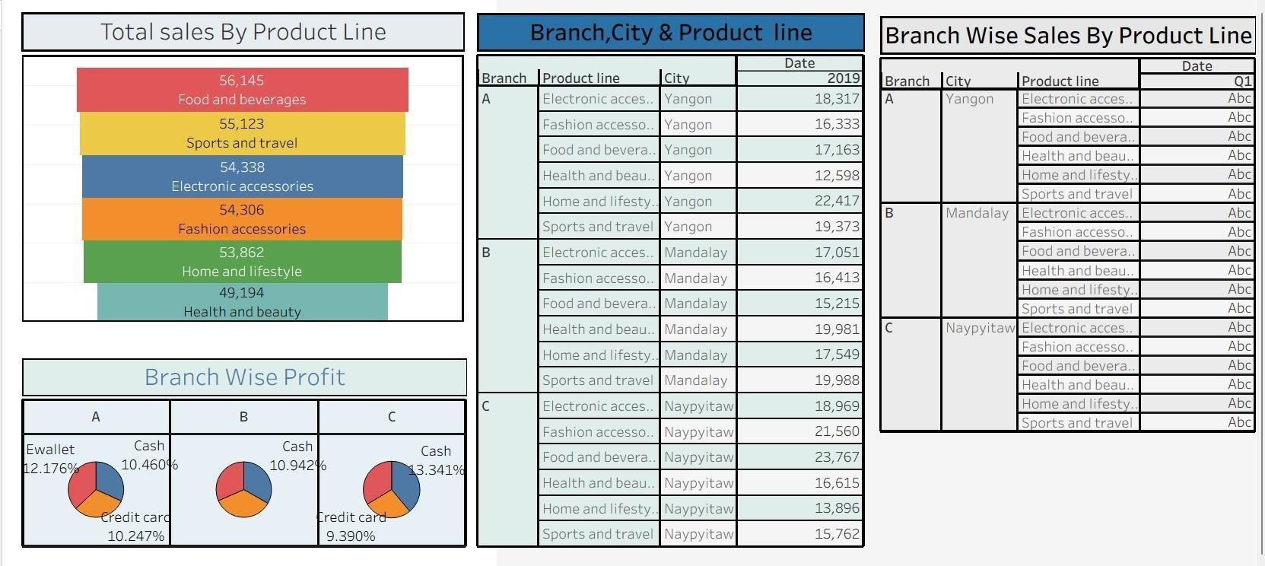

# Conclusion:

Thisinteractivedashboardmadeiteasytounderstandwhichproductsand

branches performed best. It also helped identify differences between member and normal customers. These insights can be really useful for planning offers, improvingcustomerexperience,andmakingbetterbusinessdecisionsbasedon data.